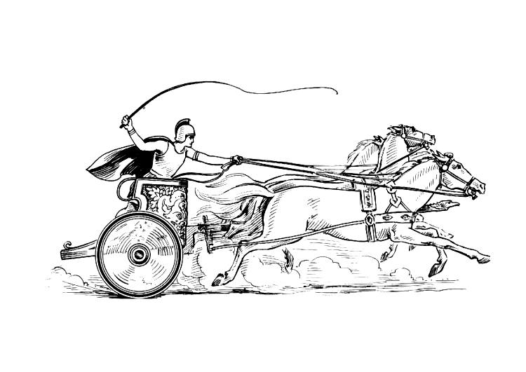

Manduessedum - Mancetter Village

(Place of War Chariots)

**M**ancetter **P**arish **C**ouncil

Serving the People of Mancetter and Ridge Lane

**PARISH COUNCIL MEETING**

**OF THE PARISH OF MANCETTER**

Minutes of an Extraordinary Meeting of the Parish Council of Mancetter,

held on Monday 10th February 2025, at the Schoolroom

of St Peter’s Church Mancetter, commencing at 6.30pm.

**Present:**

**Chairman** Mr T Hopkins.

**Parish Councillors** Mr H Blackburn,Mrs G Forknall, Mr P Mann, Mr J Tither.

**Parish Clerk** Mrs E Higgins.

**Item 1 – Welcome and Apologies.**

Mr T Hopkins welcomed everyone to the meeting where the council accepted apologies received from

Parish Councillors G Davis who was out of the area, and S Healy due to illness.

Glynis Forknall will no longer be a tenant of the allotments during the financial year 2025/2026 and

therefore, a quorum of three councillors were present to authorise financial matters.

**Item 2 –** **Notice of Interest.**

Interests were declared by Councillors Hopkins and Tither who are allotment holders in Ridge Lane.

**Item 3 – Review the Current Allotment Rents, Waiting List, and authorise the Chairman to collect payments on behalf of the Parish Council**

Currently allotment rental income totals £376.00 per year when all plots are allocated. The parish handyman opens and closes the allotment gates daily, and maintains the communal roadway. The council have not directly allocated any additional expenditure against the rent during this financial year.

It was proposed by Harry Blackburn, seconded by Peter Mann and agreed unanimously by the quorum, to leave the rental amounts at the same price for the forthcoming year.

Trevor was authorised to collect the allotment rents and was given the receipt book and current waiting list details by the Clerk. Should any holders wish to downsize or relinquish a plot then the waiting list will be applied in date order. Councillor Hopkins will write a cheque for the total rent to the council, to reduce banking administration costs.

**Item 4- PAP/2023/0324 – White Hart Inn Ridge Lane.**

A report has been forwarded to the council following the applicant’s response to the independent Road Safety survey. All previous comments will stand, and the Parish Council will be checking that the application goes back to the Planning Board before determination. Emergency vehicle access, on street parking issues and the location of the bus stop will be emphasised alongside the right of way across the existing pub car park.

**Item 5 – Soil Heap Reduction Quotation**

It was proposed by Councillor Blackburn and seconded by John Tither to accept the quotation of £700 + VAT to level out the soil heap situated in the future cemetery field, and use it to build up the low areas within the cemetery, in preparation for future burials.

**Item 6- Date of Next Meeting:**

Tuesday 25th March, 2025

7.00pm Schoolroom, St. Peter’s Church

As no further issues were raised the meeting closed at 7pm.



Manduessedum - Mancetter Village

(Place of War Chariots) **M**ancetter **P**arish **C**ouncil Serving the People of Mancetter and Ridge Lane